Exercise 6.

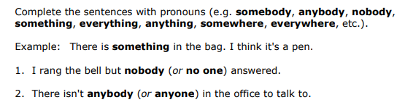

3. He won´t get anywhere without qualifications.

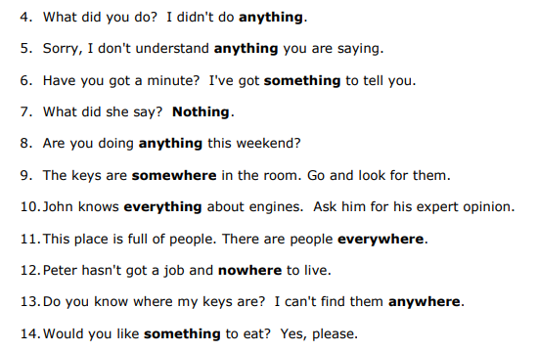

Exercise 7.

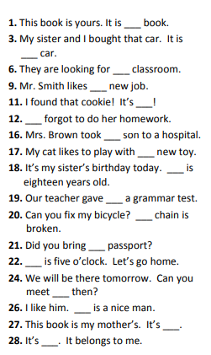

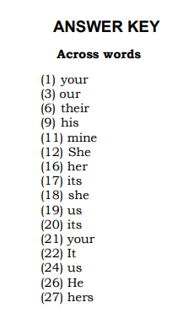

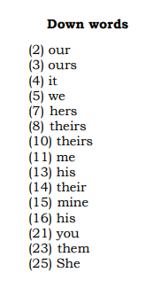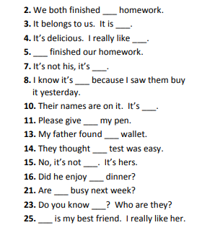

Exercise 8.

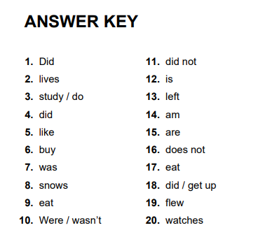

Exercise 9.

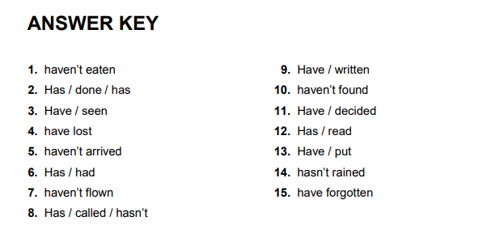

Exercise 10. Complete the sentences with the correct question tags

1. The Chapmans are going on a cruise, aren't they?
2. A rooster can't lay an egg , can it?
3. Mr. Johnston hasn't finished his painting , has he?
4. Jennifer won't finish the housework on time , will she?
5. Sharon goes for a walk at weekends , doesn't she?
6. Brian wants to keep a lizard as a pet , doesn't he?
7. Alfie has eaten at a Chinese restaurant , hasn't he?
8. Brown bears don't live in the North Pole , do they?
9. Harry and Amelia got married last Saturday , didn't they?
10. Mr. Lee didn't come to the wedding , did he?
11. Grace doesn't want to go shopping , does she?
12. Daisy's father isn't an athlete , is he?
13. Mark wasn't playing football in the garden , was he?
14. Let's go to an Italian restaurant and have pizza , shall we?
15. Mrs. Scott is playing golf at the moment , isn't she?
16. Isabella was at school yesterday morning , wasn't she?

Exercise 11.

